INFORMATION MANAGEMENT

EXERCISE 2

1. Write the SELECT statement to extract the ids of employees who are more than 30 years of age.

SELECT emp_id FROM employee_data WHERE age > 30;

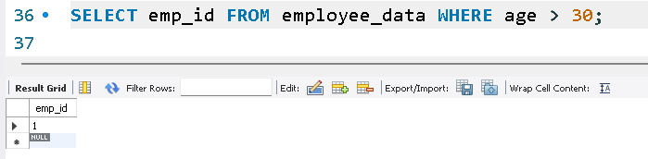

2. Write the SELECT statement to extract the first and last name of all web designers.

SELECT f_name, l_name FROM employee_data WHERE title = 'Web Designer';

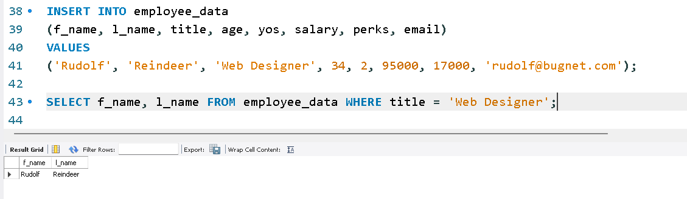

3. What will the following SELECT statement display:

SELECT * FROM employee_data WHERE salary <= 100000;

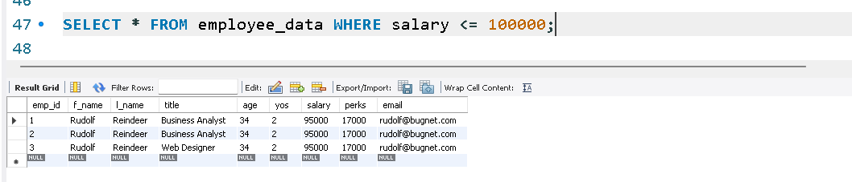

4. How will you display the salaries and perks for employees who have more than 16,000 as perks?

SELECT salary, perks FROM employee_data WHERE perks > 16000;

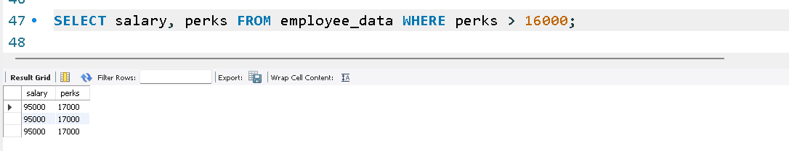

5. List all employee names (last name followed by first name) who hold the title of Marketing Executive.

SELECT l_name, f_name FROM employee_data WHERE title = 'Marketing Executive';

